**Need Being Addressed:**  Parse various types of data files (.txt, .csv, .dat, .tlab) uploaded to the website in order to automatically populate the database.

**Design Pattern Solution:** Factory Design Pattern from Creational Patterns

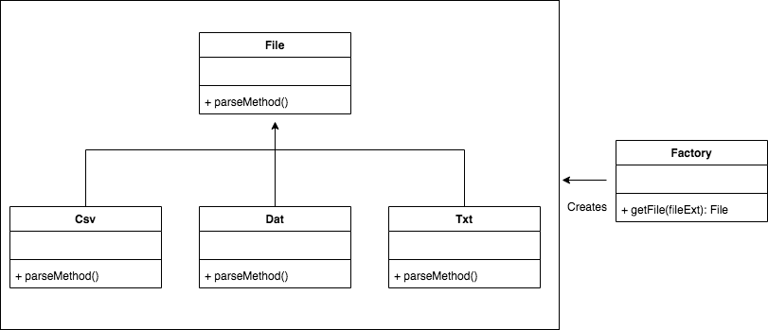

**Reason**: In order to process various types of file formats it might be beneficial to create a factory design pattern which takes a single argument (fileExt) and returns a parser for that particular format.

-------------------------------------------------------------------------------------------------------------------------------

**Need Being Addressed:** Create an interface where the competitor does not need to see the platform-dependent details of the program

**Design Pattern Solution:** Bridge Design Pattern

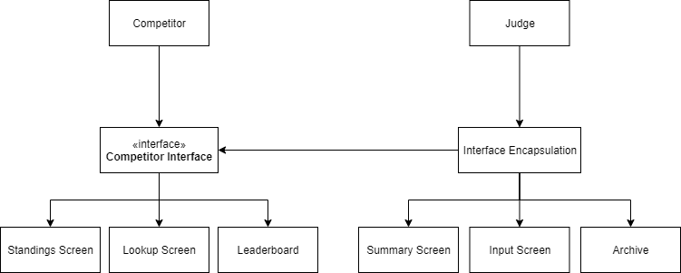

**Reason:** For the competitor to be able to easily access the screens that they want to see, separating the 2 different interfaces (judge and competitor), would be beneficial to both parties as they do not need to see what they don’t need

**Need Being Addressed:** Easily move data from the application to the standings screen

**Design Pattern Solution:** Observer Design Pattern

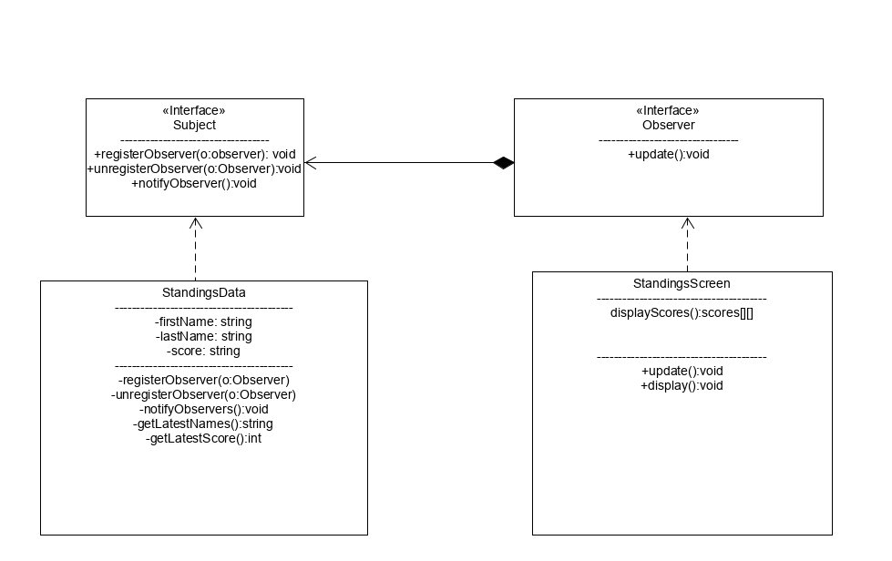

**Reason:** Allow for live updating of standings screen and allows for better flexibility with a one-to-many dependency